**Viking Motorsports Digital Dashboard**

**Users Manual**

**Rev 1.1**

**May 2015**

**Getting Started**

The Viking Motorsports Digital Dashboard System is comprised of a 4D Systems LCD screen and a custom circuit board based on the Arduino Due. The 4D Systems LCD screen is capable of resistive touch and the feature has been utilized in this package to provide for debugging capabilities. A driver should never need to touch the screen while driving.

Functionality of the digital dashboard has been kept simple to allow the driver and their crew to view information on the car with minimal hassle. Ease of use is a top priority with this project.

**The Main Screen**

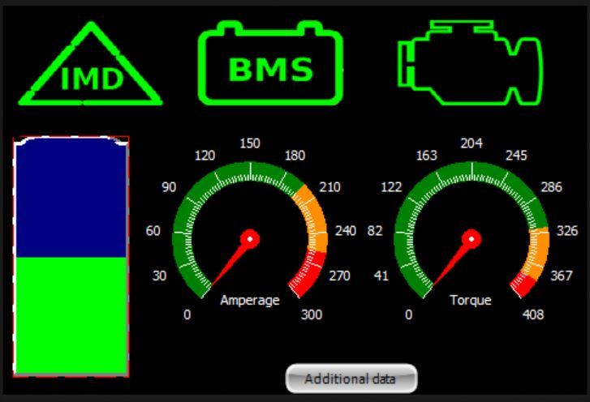

The main screen of the Digital Dashboard displays only the most important information for the driver while they are driving. Data displayed on the main screen includes motor torque, motor current, battery level, and IMD, BMS, and RMS system errors.

When an error occurs on the IMD, BMS or RMS sub-systems, their respective icon on the main screen will change from green to red. A green icon indicates there are no errors with the sub-system. A red icon indicates one or more errors with the sub-system.

The RMS and BMS icons are touch enabled. A user can touch either of the icons to be taken to a sub-screen that shows more in-depth information about the current errors on that sub-system. See the RMS/BMS Sub-Screen sections for more information.

Finally, there is a button at the bottom of the screen named *additional data*. Touching this button will take the user to a sub-screen that displays all data that the device receives on the addiontional information sub-screen. See the additional information sub-screen section for more information.

**RMS Sub-Screen**

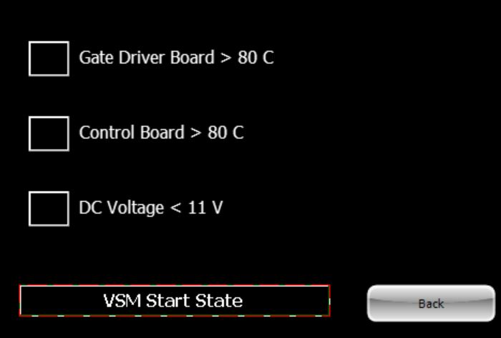

When an error occurs, the box next to the error will turn yellow. The RMS Sub-Screen contain warning LEDs for the following error conditions.

|  |  |
| --- | --- |
| **RMS Errors** | **Error Condition** |
| Gate Driver Temperature | Greater than 80°C |
| Control Board Temperature | Greater than 80°C |
| 12V Rail Voltage | Less than 11V for two seconds |

On the bottom of the RMS sub-screen there is a button that the user can touch to return them to the main screen.

**BMS Sub-Screen**

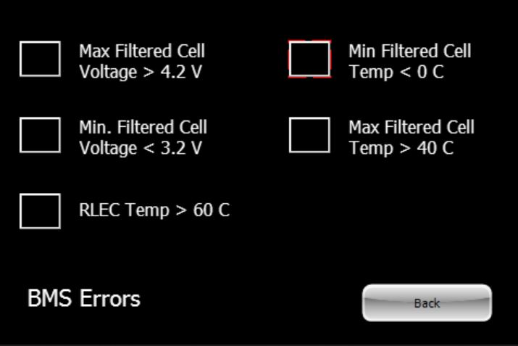

When an error occurs, the box next to the error will turn yellow. The BMS Sub-Screen contain warnings LEDs for the following error conditions.

|  |  |
| --- | --- |
| **BMS Errors** | **Error Condition** |
| Maximum Battery Cell Voltage | Greater than 4.2V |
| Minimum Battery Cell Voltage | Less than 3.2V |
| RLEC Temperature | Greater than 60°C |
| Maximum Battery Cell Temperature | Greater than 40°C |
| Minimum Battery Cell Temperature | Less than 0°C |

On the bottom of the BMS sub-screen there is a button that the user can touch to return them to the main screen.

**Additional Information Sub-Screen**

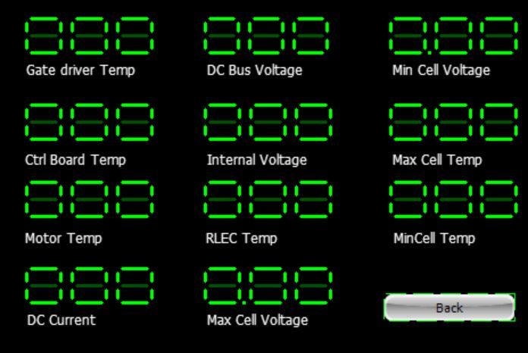

The additional information sub-screen displays all of the data that the dashboard collects from the car. This screen will have little to no use while driving the car. It has been included to assist in fixing issues with the car when a failure occurs.

On the bottom of the additional information sub-screen there is a button that the user can touch to return them to the main screen.